Report Information – KS4

Attendance
The target is 100% to give the best opportunity for the student to make good progress.

Previous Assessment Information
Key Stage 2 Standard Attainment Tests (SATS – Year 6)
Most students arrive at the Academy with attainment levels in English and Mathematics. The National average at the end of Key Stage 2 is level 4.

Progress Expectations
Progress will be tracked and measured on a triangulation of summative and formative assessments. This will be based on the content and skills of the course taught to date.

ATL
Attitude to Learning is an indicator of the overall effort that the student is displaying:

- 1 = Outstanding
- 2 = Good
- 3 = Requires Improvement
- 4 = Inadequate

H/W - (Homework/Coursework Concerns)

CATS (Cognitive Ability Tests):  CATS are a measure of a range of reasoning skills.  The tests look at reasoning with three types of symbol: words, numbers, and shapes or figures.  Non Verbal Reasoning – Shapes or Figures  Verbal Reasoning – Words  Quantitative Reasoning – Numbers  Spatial Reasoning – Spatial Ability  The final measure in the CAT category is the Mean which is the average of all four tests.  The average Mean Score is 100. |  | Year 9, 10 & 11 Reports  Current assessments will be based on the progress that students are making across each of their subject areas. This will be communicated with you through reports as “Above, Making or Below Expected Progress”.  Progress 8  Progress 8 aims to capture the progress a student makes from the end of Primary school to the end of Secondary school.  This score is a measure of progress across 8 subjects, the greater the progress score being the greater progress overall.
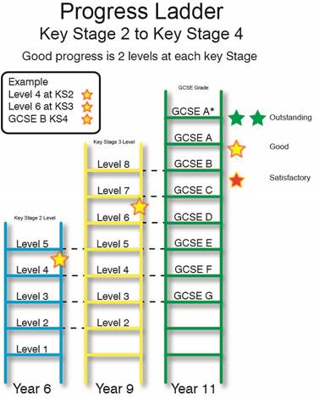
Note
As you will perhaps be aware, in the last few years the education system has been subjected to many changes. In March 2014, the coalition government embarked on a radical programme to improve the assessment and examination systems across England with schools required to abandon the use of levels in Key Stages 1, 2 and 3 and GCSE grades were also to change from A* - G judgements to a new 1-9 system. Ministers say that this will bring England's exam benchmark up to the level of students in the world's leading economies such as China.
Subjects will be marked under the new system, with more subjects having begun to teach newly constructed courses from September 2016.
Please be aware that progress may fluctuate due to the student’s aptitude for a particular topic or skill. There should be an upward trend in progress over the year. If you have any concerns about progress in a specific subject, please contact the subject teacher or subject leader.

