Ambitions Academies Trust: Proposal to make a significant change to an open academy.
This proposal is published in compliance with the Department for Education ‘Making significant changes to an open academy and closure by mutual agreement. Departmental guidance for all types of academy trust’. November 2019.
Proposal to:
- Close the sixth form at St Aldhelm’s Academy
Academy Trust and School details:
The proposer is Ambitions Academies Trust
General correspondence should be electronic only and addressed to: jon.webb@aat.education. Consultation responses should be sent either electronically to this email address, or posted to Ambitions Academies Trust Office, Manorside Academy, Evering Avenue, Poole, BH12 4JG.
The proposal relates to St Aldhelm’s Academy, Herbert Avenue, Poole, BH12 4HS

Implementation date and proposal:
It is proposed to formally and retrospectively close the sixth form at St Aldhelm’s Academy from August 31st 2016.
The academy’s net capacity of 900 does not currently include the sixth form and therefore the overall capacity of the academy is unaltered.
The age range of pupils attending the academy will be 11-16.

Objections and comments:
Objections and comments regarding this proposal should be sent via email to: jon.webb@aat.education. All responses must be received by 23.59 March 1st 2021.
Alteration description
St Aldhelm’s Academy provides 6 forms of entry in each year group for secondary aged children 11-16. There is capacity for 900 pupils *(subject to building works being undertaken which will enable current facilities being adapted to increase classroom space for children aged 11-16).
School Capacity:
900
Implementation:
The proposal will be implemented by Ambitions Academies Trust.
Additional site:
The school would remain fully operational throughout the closure of the sixth form. No additional site is required.
Objectives:
The key objective of this proposal is to support Bournemouth, Christchurch and Poole (BCP) Council in its statutory duty to provide sufficient school places for children aged 11-16.
The number of young people requiring a school place over the next three years has been well planned for across the local authority particularly between 2021-2023, as each year is viewed as a ‘bulge’ year with regard to the capacity of schools locally to meet projected admission requirements. St Aldhelm’s Academy currently requires additional building work to convert the facilities used to deliver sixth form courses to educate pupils between the ages of 11-16.
Impact on other Educational Institutions in the area:
There is not expected to be any impact on other schools or post 16 institutions in the area. The last cohort of sixth form students who attended St Aldhelm’s Academy left in 2016 and the average size of each cohort was between 10 and 15 students.
Consultation:
Statutory requirements to consult in relation to this proposal are being complied with as per the Department for Education ‘Making significant changes to an open academy and closure by mutual agreement, Departmental guidance for all types of academy trust.’ November, 2019.
A list of stakeholders who have been sent consultation packs inviting them to express their views can be found in appendix 1.

Project costs:
There are no costs associated with the closure of the sixth form.
Age range:
The age range of St Aldhelm’s Academy will reduce from 11-18 to 11-16. (Year 7 – Year 11)
Need or demand for places:
Within the Bournemouth, Christchurch and Poole Local Authority, there was sufficient provision to meet the needs of all students who wish to study a further education course. St Aldhelm’s Academy has only ever offered a very narrow post 16 curriculum consisting of BTEC Sport, Hair and Beauty and Service Maintenance Engineering.
BCP council supports St Aldhelm’s Academy closing their 6th form permanently. It would not result in an insufficiency of sixth form places issue, and the Local Authority are not supportive of sixth forms that are not financially viable such that the provision can be at risk of mid-course changes / withdrawal of courses as this can lead to young people to have to repeat sixth form years as they switch between providers.
The following table contains highlights information about sixth form pupil on-roll numbers within BCP from the October 2019 School census and reflects the choice of sixth form providers that would remain available to pupils within BCP.

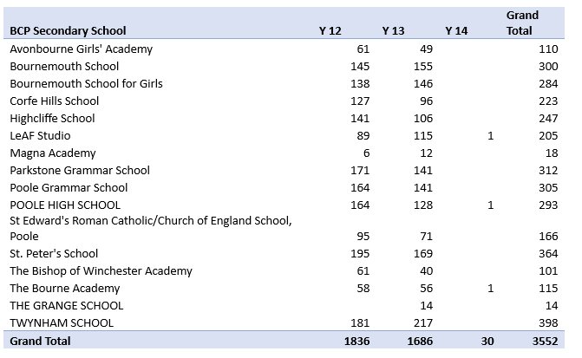
Deadline and how you can respond to the consultation:
Copies of this proposal can be obtained from:
AAT website: http://www.ambitions-academies.co.uk/ St Aldhelm’s Academy website: http://www.staldhelms-academy.co.uk
The consultation runs from Monday 18th January 2021 to Monday 1st March 2021. During this time, any person may object to or make comments on the proposal by
Emailing jon.webb@aat.education.
The deadline for responses is 23:59

Appendix 1
Consultation Forms and Responses
Consultation Documents have been made widely available to:
- Families of all pupils of St Aldhelm’s Academy
- The Governing Body of St Aldhelm’s Academy. • School staff at St Aldhelm’s Academy
- Head Teachers across the BCP Council area including those of Independent and Non- Maintained Special Schools.
- Local Member of Parliament
- Trade Union representatives
- Local Children’s Centres
The consultation document is available on the BCP Council website as well as the school’s website.

