History Home Learning @ SAA
Year 9 Term 1: Law makers or breakers: Did the Suffragettes win votes for women in 1918?
You will be set History home learning once every two weeks at SAA. You MUST choose ONE home learning task from the correct column to complete. If you start with the easiest task you MUST complete a more challenging task for your next two assignments.
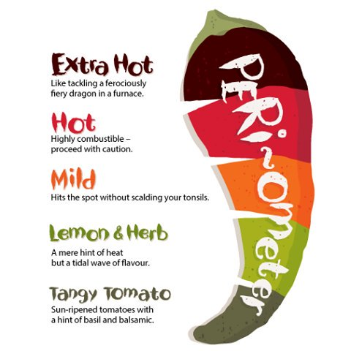
NB. You will be provided with this sheet at the beginning of each topic. There will also be a soft copy uploaded to your Microsoft Teams Class where you can also upload your work if preferred.
Home Learning 1 | Home Learning 2 | Home Learning 3
Local Historian  https://www.dorsetecho.co.uk/news /5364367.the-fight-for-equality/  Using the link above for research, create a piece of work which explains the impact the Suffragette movement had on Bournemouth and Poole. | Elsewhere in the World…  Useful Links:  https://www.womenshistory.org/resources /general/woman-suffrage-movement  Research the Suffrage movement in the US during the early 20th century. Create a piece of work which shows what you have learnt. | Creative History:  https://www.museumoflondon.org.uk/ discover/suffragettes  Choose one of the Suffragette artefacts from the Museum of London online collection and create a museum exhibition card for the chosen piece.  - Picture  - What it is and date  - Why it is significant to the Suffrage movement.
Timeline Task:  Create a timeline that shows the key events of the women’s suffrage movement from 1897-1928. | Historical Reporter:  Write a newspaper article or create a film with the Headline: Suffragettes: campaigners or terrorists? | BAME History:  Using the following link: https://www.bbc.co.uk/news/in-pictures-42837451  Read the article and then choose one of the suffragettes and create a piece of work about their contributions.
Quiz Master:  Create a 20-question quiz with answers on one of the following topics:  - Women before 1900  - Suffragists Vs Suffragettes | Talk like a Historian:  Create a set of prompt cards for each of the key words and their meanings:  Suffrage, Suffragist, Suffragette, Martyr, Munitions, Parliament, Public Opinion. | Quiz Master:  Create a 20-question quiz with answers on one of the following topics:  The Suffragettes  Emily Wilding Davison  Suffragettes during WWI
Poster:  Create a poster summarising this topic. You should include:  Title – Suffragists Vs Suffragettes  Our key words and their meanings  Pictures, images and colour | On this day:  https://www.onthisday.com/  Using this link, find out about and write down two important events which took place on the same date as your birthday. | Poster:  Create a poster summarising this topic. You should include:  Title – Did the Suffragettes win votes for women in 1918?  Our key words and their meanings  Pictures, images and colour

