1 October 2020
Dear Parent/Carer,
I wanted to take this opportunity to remind you of our uniform expectations but also to advise you of a further optional item you may wish to purchase for your son/daughter for the winter. I am pleased to say that the vast majority of our students have returned looking really smart and wearing the correct academy uniform.
Thank you for your patience with the delay in uniform deliveries from our uniform provider Brigade. They have assured me that all orders should now have been dispatched.
I wanted to support your son/daughter by reminding everyone of the uniform expectations at St Aldhelm’s Academy. This will ensure all are wearing the correct uniform and are warm throughout the day. As the weather begins to get cooler and we are asking students to wear their academy PE kit on days when they have PE or Dance, we wanted to offer a further option in the academy PE kit.
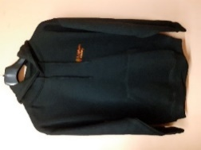
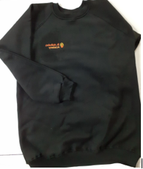
Currently I have asked that if your child wishes to wear something over the top of their PE kit they can wear EITHER a Performing Arts hoody (if they have one of these) OR their normal academy jumper or blazer. However, having spoken to our uniform provider ‘Brigade’ we are now able to offer the option of a black SAA sweatshirt or hoody with our academy logo on. Please see the pictures below.

Sweatshirt Hoody
The cost of the sweatshirt is from £9.95 and the hoody from £12.95. This can then be worn on the days when students have PE/dance over their academy PE top. This is an additional item so if you do not wish to buy it, your child will need to wear their school jumper for extra warmth. Other hoodies/jumpers will not be allowed. If you wish to order one of these please go to the Brigade website: www.brigade.uk.com. Brigade will not charge you anything for delivery as we are conscious you have already had to do a uniform order and paid delivery for this. All orders will be sent weekly to us here at the Academy and we will distribute the orders to students.
May I also take this opportunity to remind you of our uniform expectations:
Academy uniform students must wear:
- Trousers/Skirt (Tights under the skirt not leggings!)
- White Shirt
- Tie
- St Aldhelm’s Academy Jumper (This is optional however a good option in the winter months)
Hoodies not allowed!
- Blazer (This must be worn throughout the day)
Academy PE kit for PE lessons/Dance
- Plain black leggings/joggers
- SAA Academy PE top (from Brigade)
- Black SAA PE sweatshirt or hoody (purchased as an optional extra from Brigade) or students should wear their school jumper over their PE kit
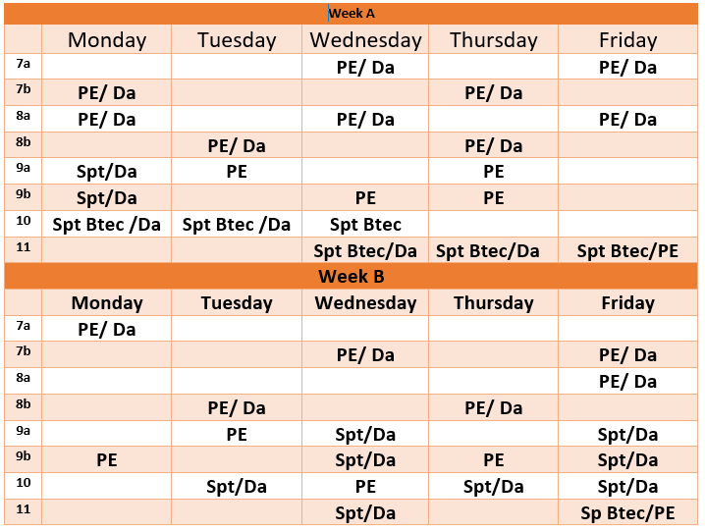
Can I remind you that students should only wear their academy PE kit on the days they have PE or dance lessons. Please see the timetable below which confirms the days your child should be wearing PE kit. Please support us with this. If students do not arrive in the correct uniform for the day we will be contacting you to ask if you can bring it into school so they can change.

The uniform plays an important role in the high expectations of the academy and must be worn at all times. May I also remind you that students should have the academy bag (purchased from Brigade) which they must bring to school every day. This will enable them to carry everything they need for the day. A reminder that hair colour and style must be natural and appropriate for the Academy.
Thank you for your support with these matters. If you have any questions, please do contact your child’s tutor or Head of Year. A reminder if you wish to order the additional PE top, please visit the Brigade website at www.brigade.uk.com
Yours sincerely
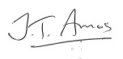
Jo Amos
Principal

