21 October 2020

Dear Parents and Carers

Re: Planned changes for after half-term
I hope your son/daughter has enjoyed being back at school this half-term. We have certainly enjoyed having our students back in school and working with them. I am pleased to inform you that students have settled really well into the new routines. I know there has been some minor disruption for some students who have had to self-isolate owing to our confirmed positive Covid cases and that an increasing number of students have had to self-isolate owing to being symptomatic. I want to take this opportunity to thank you for your support as we have dealt with these issues.

This half-term has certainly been an unprecedented one as we operate in these difficult times and with all the new guidance. I know it is also changing on a daily basis. Thank you for your support with changes. I know we have had to move to virtual parent consultation evenings and at the time of writing these have taken place for our Year 7 and Year 11 parents and carers with Year 9 taking place this week. Thank you for embracing this new change. Hopefully it has allowed you to still ‘meet’ with your child’s teachers and gain feedback on how they have returned and how they have been working this half-term. You will also be aware that we have set up our remote learning and it is important that students know and understand how to access their Microsoft TEAMS account.

In this letter, I want to share with you some changes to routines for after half-term and to remind you of some of our expectations. Firstly, I want to confirm that Monday 2nd November is an INSET day so students will be expected back in the academy on Tuesday 3rd November.

Zones
As you will be aware from my previous correspondence, I have zoned the school and each year group is based in a specific area of the school. There will be one change to this with Year 7 and Year 8 swapping their zones. Year 7 will be based in the Hub building after half-term and Year 8 in the main building on the ground floor. Year 9, 10 and 11 remain in their same zones. Students continue to use some of our specialist rooms such as the IT suites, library, workshops, catering room and when they have lessons in specialist lessons or PE they will line up on the playground before being collected by their teacher and escorted to their room.

Entry/Exit
There are some tweaks to the entry and exit points.
Year 7 Catering gate by the Hub. Gate opens at 8.20am students need to be in by 8.35am
Year 8 Doors at the student exit (these are the doors opposite the leisure centre car park). Doors open at 8.20am and students need to be in by 8.30am please.
Year 9 Main reception. Doors open at 8.35am.
Year 10 Gates at the end of the car park by the leisure centre. Gates are opened at 8.35am
Year 11 Theatre doors. Doors open from 8.20am. Students must be in by 8.35am.

A reminder that when students are arriving to and from school they must socially distance from members of the public and other year groups and not to congregate on paths where members of the public may be trying to pass to access other areas of the site.

The school day
The structure of the school day remains the same with students having their normal five lessons a day and two breaks. As you will be aware, we have staggered our social times. Students know well the routines for queuing for food in the canteen and getting and eating their food. Students have a designated time to go to the canteen and there will be two separate entry and lining up points for each year group. After they have bought their food and eaten it, there will be an outside area specific for each year group to go to. If the weather is poor and it is raining, there is a contingency plan to use inside spaces.
Money for food
A reminder that we do run a cashless system on site and so please ensure your child knows whether they have money credited on their student identity card. All money on students’ cards (unless your child is entitled to free school meals) must be added via Paypoint (you would need to request a bar code from the finance team) or ParentPay. If your child does lose their card, a new one can be purchased for £1 (this is to cover the cost of a replacement card and the reprinting of it) which you can do by ordering on ParentPay.
Face Masks/coverings
A reminder that we have strongly advised that staff and students wear a face mask/covering in communal areas of the school when they are arriving and exiting, queuing in the canteen and moving around the academy. Please ensure your child has a face mask/covering with them every day. We are aware some students may be exempt, please communicate with your child’s Head of Year so we can issue them with a card which says they are exempt.
Equipment
A reminder that your child should have their SAA academy bag (available from Brigade)with them every day and inside their water bottle, planner and their pencil case for the day. They should have their ID card on them every day too and a face mask/covering.
Uniform
A reminder that students should be wearing full Academy uniform including their blazer every day. I believe all delayed orders from Brigade have now been fulfilled but if you have any issue still with uniform please contact your child’s tutor or Head of Year. On the days that students have PE they are allowed to come to school in their full Academy PE kit (please refer to timetable below). To clarify academy PE kit consists of: plain black joggers/leggings or shorts; the SAA PE top and you will know from my recent correspondence that there is a further option to buy an SAA PE sweatshirt or hoody (see link to Brigade on website) to wear over their PE top. I know many of you have already purchased these. They are still available to order - you need to order from Brigade but they will deliver free of charge to the school and we will distribute any orders to students and inform you when we have done this via text message. If you would prefer not to purchase this optional PE kit, students should wear their normal academy SAA jumper over the top as an additional layer of warmth! They should not be wearing any other hoody/sweatshirt. If students wear them they will be asked to remove them.
If you have any concerns re: academy uniform or academy PE kit, please speak to your child’s tutor or Head of Year in the first instance. Thank you for your support with this matter.
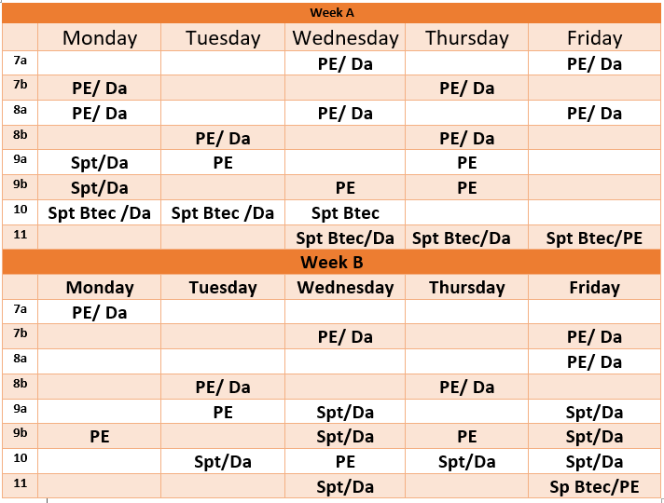
After school Clubs
I am pleased to inform you that after school clubs will be starting up after half-term. More details will follow on this so please check out our social media and we will email out further details too.
Parents on site
A reminder that parents and carers will only be allowed on site with an appointment and ideally these need to happen at the end of the school day when we have more space to meet with you. We would therefore ask that you call the academy reception on 01202 732500 or email office@staldhelms-academy.co.uk to make an appointment rather than turning up at reception.
Finally, a reminder that when we return after half-term it is Week B. So, students will have the lessons as per Week B on their timetable when they return on Tuesday 3rd November. The information I have shared in this letter can be found on the academy website here: http://www.staldhelms-academy.co.uk/academy-information/plans-for-september/
We very much look forward to welcoming all of our students back after half-term. Students should be very proud of all that they have achieved this half-term and we look forward to continuing to work with them next half-term. Continue to stay safe and I hope you and your families have a wonderful half-term break.
Kind regards
Jo Amos
Principal

