BTEC Sport
Unit 1
Week 6
Fitness Tests

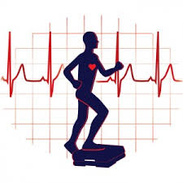
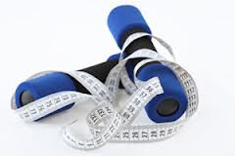
Testing components of fitness

In order to improve our fitness, first we need to test our current levels of fitness / performance in all areas. This will help identify which areas are strengths and which need improving.
What are the main reasons why fitness tests are performed?

When conducting fitness tests we need to variables that might affect the results. In the table below write down how these variables can affect fitness testing:
Variable | Explanation
Validity

Accuracy

Equipment

Experience of the person testing

Fill in the gaps in the sentences using the word bank at the bottom of the page to show how tests can and should be carried out:

- Administer the test according to the correct _________________.
- Use the same ________________ each time you do the test.
- Same ____________ apply for each test, e.g. shoes on or off for sit and reach should be the same each time the test is repeated, same step height for step tests.
- You need to stick to exactly the same ______________ every time.
- Ensure all _________________ is in good working order.
- Where possible assessment ________________ should be the same every time, e.g. air temperature will affect flexibility.
- If you do lots of tests at the same time, do them in the same ________________ each time.
- If you warm up, warm up ___________________.
- The same _____________ should do the measuring each time.
- Record results _________________.
Word Bank
instructions conditions
method equipment
rules every-time
tests person
order carefully

Fill out the following information on the 6 fitness tests detailed:
- Multi-stage Fitness Test

- What is tested:

- Equipment needed:

- Purpose of test:

- Procedure & Measurement:

- Notes:

- Draw the test:
Forrestry step test

- What is tested:

- Equipment needed:

- Purpose of test:

- Procedure & Measurement:

- Notes:

- Draw the test:
Sit and Reach Test

- What is tested:

- Equipment needed:

- Purpose of test:

- Procedure & Measurement:

- Notes:

- Draw the test:
Vertical jump

- What is tested:

- Equipment needed:

- Purpose of test:

- Procedure & Measurement:

- Notes:

- Draw the test:
Sit Up Test

- What is tested:

- Equipment needed:

- Purpose of test:

- Procedure & Measurement:

- Notes:

- Draw the test:
Illinois Agility Test

- What is tested:

- Equipment needed:

- Purpose of test:

- Procedure & Measurement:

- Notes:

- Draw the test:

