WEATHER & CLIMATE
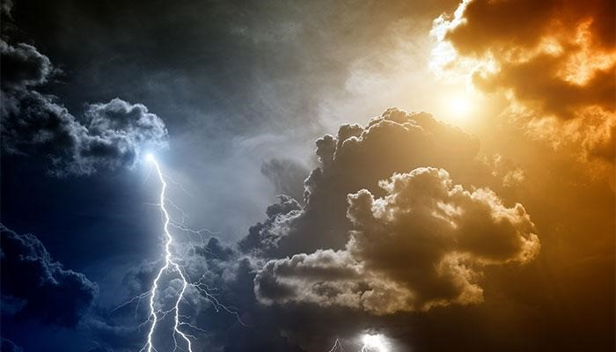
HOME LEARNING BOOKLET

NAME:__________________________________

LESSON 1 - UK CLIMATE CHARACTERISTICS
What is the difference between weather and climate?

Climate is different weather conditions that can be expected in an area over a long period, usually 30 years.

Weather is the particular conditions in the atmosphere over a
short time e.g. a day.

TASK: Decide if each statement is talking about weather or climate. Use the definitions above.

 | Weather | Climate
“I think we should move further south where it’s warmer”
“My washing will never dry today”
“It’s a beautiful day at Lords”
“December will be cold and wet”
“Where should we go for our skiing holiday this year?”
“There is too much fog to take off now.”

LESSON 2 - WHY IS THE UK CLIMATE SO VARIABLE?
The British Isles has a temperate climate. Watch the clip to help you
https://www.youtube.com/watch?v=HrO7d18DRl8

This is perhaps the most varied climate system in the world and is divided into two main types: the maritime and the continental.
Maritime temperate regions are found in areas near coasts where the sea and onshore winds provide more rain and help to keep the temperatures level throughout the year. Continental temperate regions have more pronounced dry periods and, as there is less of a moderating influence by the sea, temperatures are often hotter in summer and colder in winter.
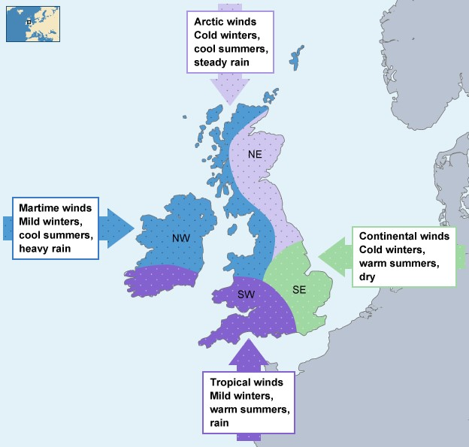
Britain is a good example of a country with a maritime temperate climate where the summer temperatures are generally cooler than further into Europe. This is because the sea has a moderating effect, keeping the land cooler in summer and warmer in winter. However, Britain does experience very changeable weather so accurate weather forecasting is difficult to achieve. Rain often comes in the form of storms which develop in the North Atlantic and blow across Britain from west to east at all times of the year. Even in such a small island, the weather, and to some extent the climate, differs from north to south and east to west. Mountainous areas get a lot more rain than the lowlands and this has a large effect on what can be grown. Lowland areas tend to be warmer and more suitable for large-scale agriculture.

TASK: Summarise the factors which influence the UK's climate?
The first has been done for you.

1. Ocean currents  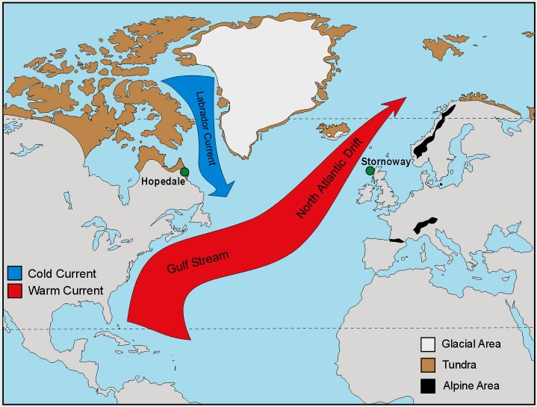 | The relatively warm waters of the North  Atlantic Drift is responsible for moderating the climate of western Europe, so that winters are less cold than would otherwise be expected at its latitude.  Without the warm North Atlantic Drift, the UK and other places in Europe would be as cold as Canada, at the same latitude.
2. Distance from the equator
(latitude)
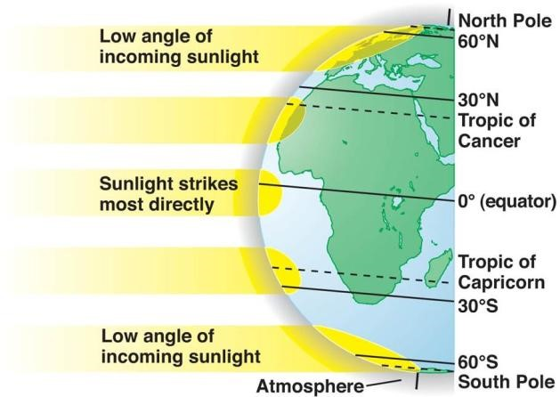
3. Altitude (height above sea level)

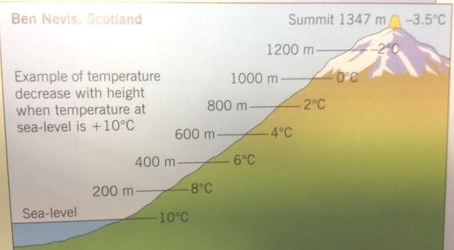
4. Prevailing winds (air masses)

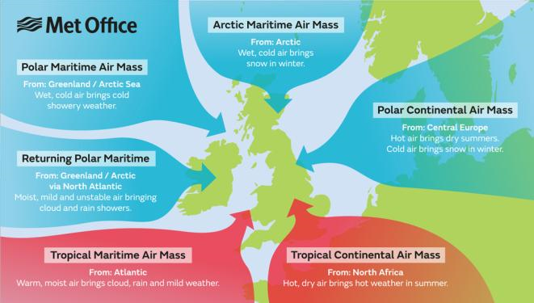
5. Distance from the sea

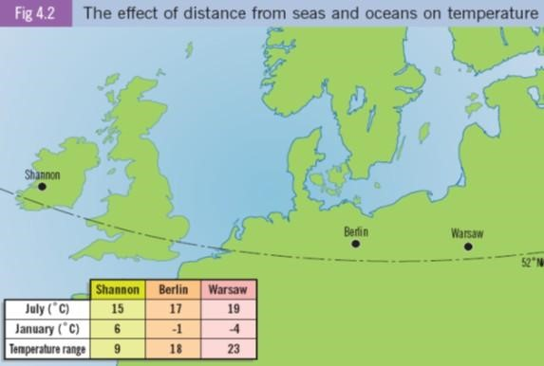

EXAM QUESTION: Compare the average temperatures for the UK in summer and winter. Use the figure. (3 marks)

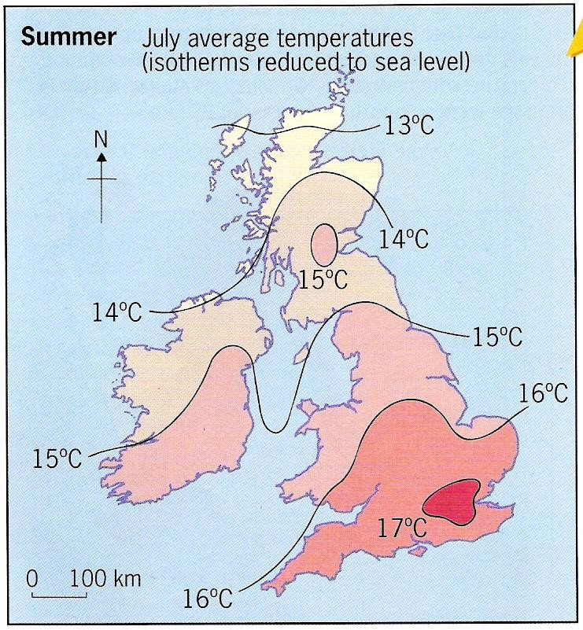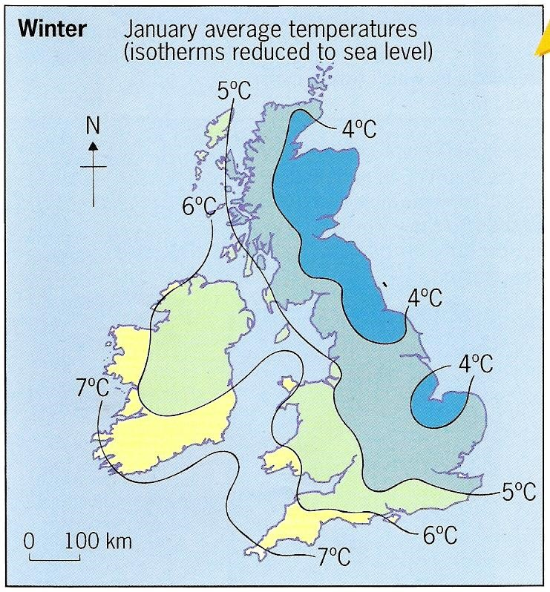
.......................................................................................................................................
.......................................................................................................................................
.......................................................................................................................................
.......................................................................................................................................

Lesson 3 - TYPES OF RAINFALL

TASK: Using the YouTube video, draw a diagram and explain each type of rainfall https://www.youtube.com/watch?v=DpjPIKru14w (the first one has been done for you
Relief rainfall

Diagram | 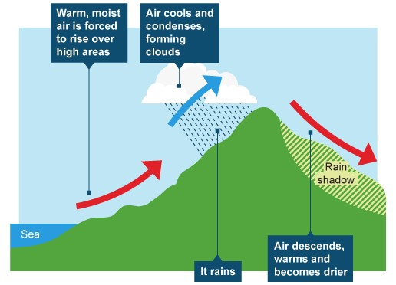
Explanation | - Warm wet air is forced to rise through evaporation over high land such as the Pennines in the UK.  - As the air rises it cools and condenses to form clouds.  - The drier air sinks, as the air sinks it warms meaning it can carry water, so there is little precipitation on one side of the mountain known as a rain shadow.

Convectional rainfall

Diagram

Explanation

Frontal rainfall
Diagram

Explanation

