**SUPPORT DOCUMENT YEAR 8 T6 W3**

**Planes para el finde (Plans for the weekend)**

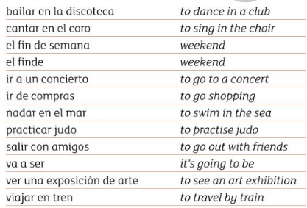

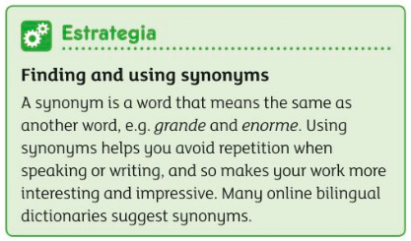

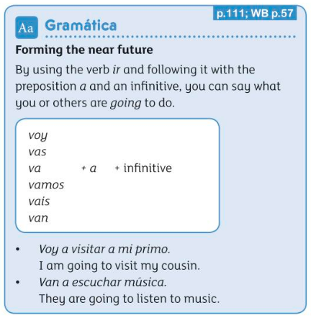

Voy a = I am going to…

Vas a = You are going to…

Va a = He/She is going to…

Vamos a = We are going to…

Vais a = Your (plural) are going to…

Van a = They are going to…