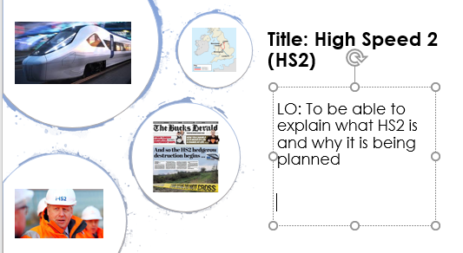
NAME
Lesson 5 – 3 for 3
- What is biofuel?

- State one advantage and one disadvantage of using biofuels? (Stretch – explain your answer and aim to write more than one of each)

- The following countries use biofuels. Write what continent they are in:

America __________________________ Canada _________________________
Brazil _____________________________ France __________________________
Australia __________________________ China ___________________________
India _____________________________ Germany ________________________

Draw your mind map in this box

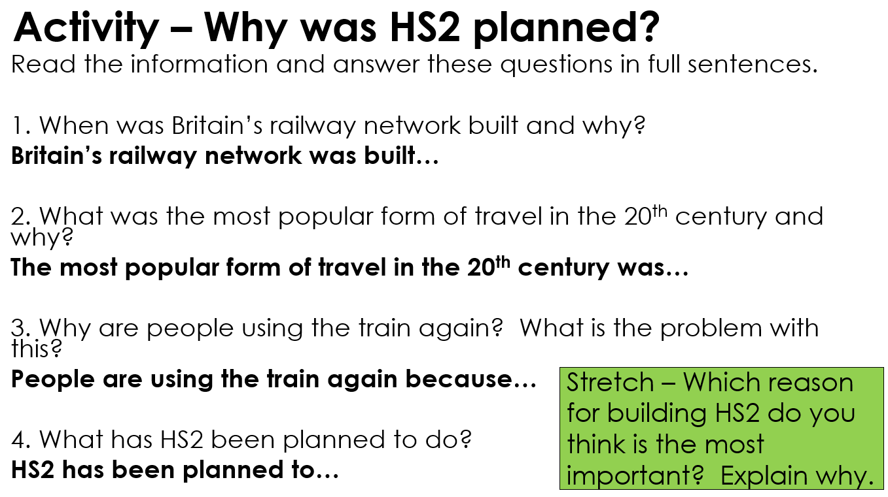
Write your answers in this box

1

2

3

4

S&C

