GEOGRAPHY HOME LEARNING

WEEK COMMENCING 22.6.20

NAME________________________

Calculating area

|  |  |
| --- | --- |
| In your exam you could be asked to calculate the area of a part of the map, for example a forest or a lake.  It can be difficult to measure the area of location on a map, as they are often an irregular shape. One method is to divide the area into a series of squares that can be measured. | **Remember:**  A grid square on an OS map is 1km by 1km. If a feature covers one grid square it will be at least 1km². |

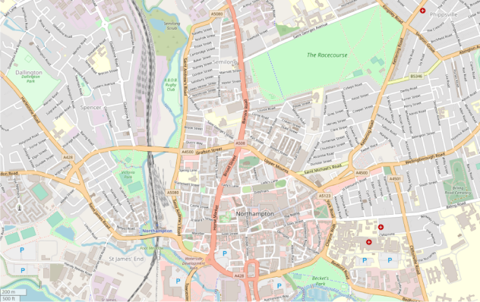

scale

© OpenStreetMap contributors

Use the scale on the map to help you to measure the area, and always remember to convert it to km instead of cm.

**Using the scale in the bottom left corner of the map, estimate the area of:**

1. The racecourse:

1. The park in Dallington (under the word Dallington):

1. The Billing Road Cemetery::

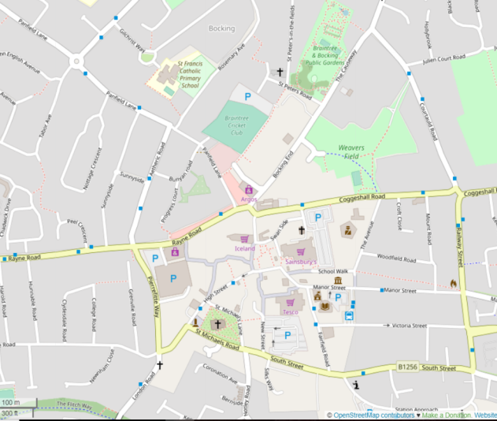

**Using the scale in the bottom left corner of the map, estimate the area of:**

1. Braintree cricket club:

1. St Michaels church and churchyard:

1. The parking area south of Tesco:

1. The public gardens:

Atlas skills – describing patterns

In your exam you could be asked to describe patterns of distribution on a map. This is a choropleth map, and shows the population density in India.

|  |  |  |  |
| --- | --- | --- | --- |
|  | Describe the pattern of population distribution in India: | | |
| **Remember:**  When you are describing, you are saying what you can see; you do not need to give reasons for the pattern as well. | | **Hint:**  You can give general statements to begin with but then you must go into more detail, for example naming specific areas where there is high/low density. | |
|  | Describe the pattern of upland areas in the UK: | | **Hint:**  You may need to look at the key to help you pick out particular areas. |
| **Hint:**  Look at the number of marks available. If there are four marks available try to pick out four pieces of information. |

OS map symbols

Test your knowledge of map symbols. Look at each symbol below and write down what it means in the box below it. Look carefully at each symbol as some symbols are very similar!

|  |  |  |  |
| --- | --- | --- | --- |
|  |  |  |  |
|  |  |  |  |
|  |  |  |  |
|  |  |  |  |
|  |  |  |  |
|  |  |  |  |
|  |  |  |  |
|  |  |  |  |

Four- and six-figure grid references

It is important to be able to locate places using four- and six-figure grid references. A four-figure grid reference will locate a particular square on the map. A six-figure grid reference will pinpoint a location such as a school, bridge or hospital.

00

01

02

03

04

00

01

02

03

04

**Easting**

Northing

|  |
| --- |
| **Hint:**  Remember to give the Easting first and then the Northing. Always go from the bottom left corner of the square.  For example, the four-figure grid reference for the heart is 00 03. |

Give the four-figure grid reference of the following symbols.

1. **Square:**
2. **Cloud:**
3. **Circle:**
4. **Cross:**
5. **Moon:**

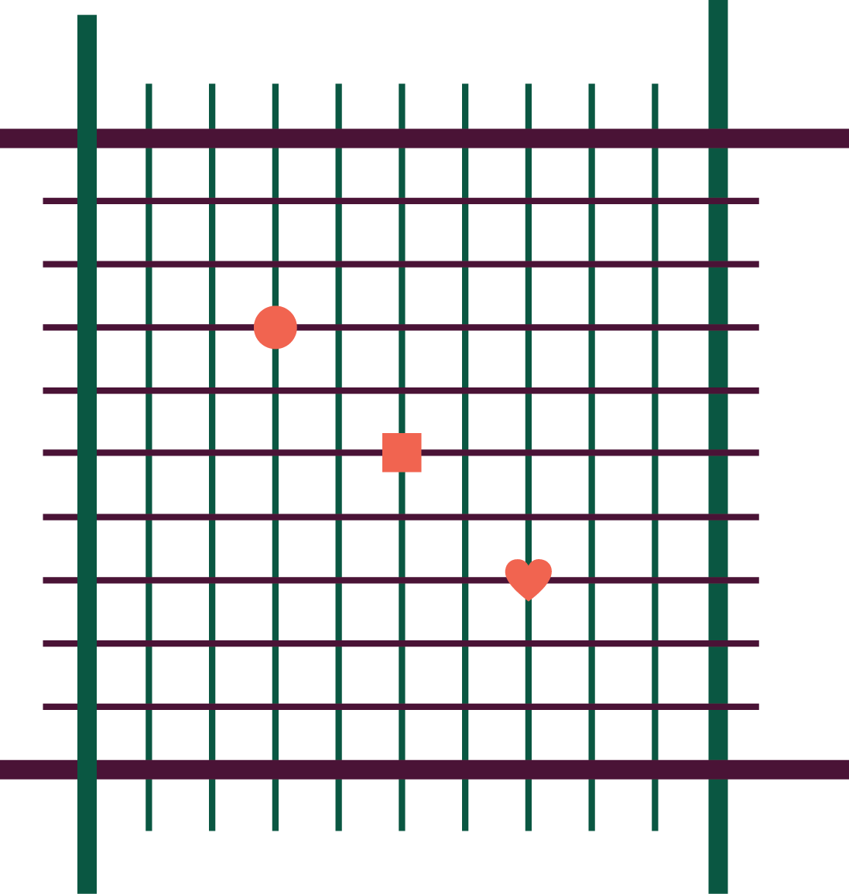

1

2

3

4

5

6

7

8

9

9

8

7

6

5

4

3

2

1

01

02

02

03

Remember to always go from the bottom left-hand corner of the square when giving a grid reference. Use the middle of the symbol as your starting point.

|  |  |  |
| --- | --- | --- |
| **Remember:**  For a six-figure grid reference you are pinpointing a particular spot within the square. The square has been divided into 100 smaller squares.  In the exam the square won’t be divided up, you will have to mentally divide it. It helps to find the centre of the square first!  The first two numbers and the fourth and fifth numbers will be the number from the four-figure grid reference.  The third and sixth numbers will pinpoint the location within the square.  **Examples:** | | |
| **Circle:** 02**3** 01**7** | **Square:** 02**5** 01**5** | **Heart:** 02**7** 01**3** |

Task:

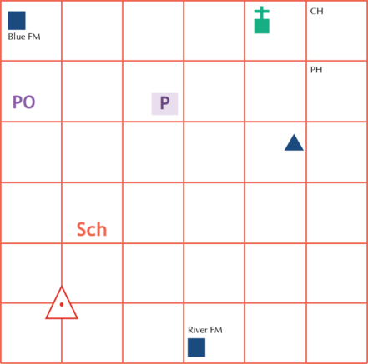

15

16

17

18

19

20

21

34

39

38

37

36

35

40

Give the six-figure grid reference for the symbols below:

|  |  |  |  |
| --- | --- | --- | --- |
| **Feature** | **Six-figure reference** | **Feature** | **Six-figure reference** |
| Blue farm |  | Church with tower |  |
| Youth hostel |  | River farm |  |
| Car park |  | Triangulation point |  |
| School |  | Pub |  |
| Post office |  | Clubhouse |  |

Task:

Draw these symbols onto the grid in the correct locations:

|  |  |  |  |  |  |
| --- | --- | --- | --- | --- | --- |
| **Windmill:** | 171 345 | **Information centre:** | 202 378 | **Bus station:** | 158 362 |
| **Nature reserve:** | 185 385 | **Viewpoint:** | 180 350 | **Campsite:** | 152 372 |

Compass directions

Complete the 16-point compass below:



|  |  |  |  |  |  |
| --- | --- | --- | --- | --- | --- |
|  | | | | **What is the compass direction from:**   1. The theatre on Southgate to Magdalen Road car park? 2. The Maynard School to Triangle car park? 3. The library to the court? 4. The church on Heavitree Road to the court? 5. The church on Dixs Field to the theatre on Southgate? 6. Magdalen Road car park to Triangle car park? 7. The car park on Eastgate to the war memorial? | |
| **Key** |  | | | | |
| Theatre | | Library | Memorial | | Court |

Scale and measuring distance

|  |  |
| --- | --- |
| Scale 2 cm = 1 km | **Remember:**  You must convert the measurement you take into the units used on the map, for example cm into km. |

Measure each of these lines and convert the measurement into kilometres:

1 cm on a 1:25000 map = 1 cm on a 1:50000 map =

On an OS map one grid square =

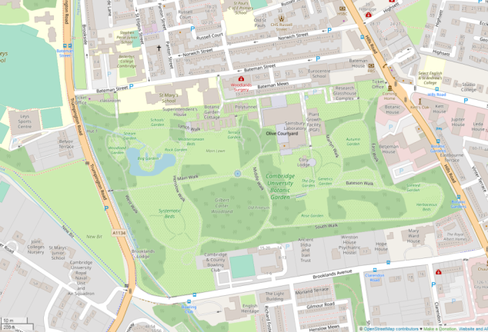

Using the scale on the map measure the distance of:

1. Brooklands Avenue
2. The width of the botanic garden at its widest
3. Norwich Street
4. The width of The Leys Sports Centre
5. Bateman Mews

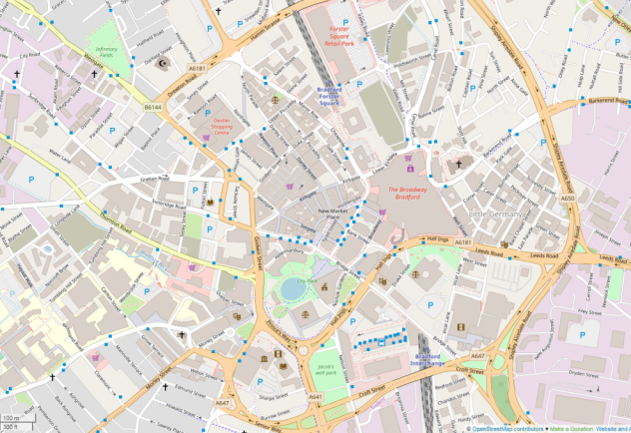

Measure the distance as the crow flies from:

1. The centre of City Park to the centre of Forster Square retail park
2. Bradford Interchange to Bradford Forster Square
3. A650 symbol to A6181 symbol on Drewton Road
4. The parking on Paradise Street to New Market Place
5. Centre of The Broadway Bradford to A650 symbol

Measuring curved-line distances

|  |  |
| --- | --- |
| Often when you need to measure distance on a map the route won’t be a straight line. One of the easiest ways to measure distance when the route isn’t straight is with a piece of string. You can manipulate the string to fit the route and then measure it with a ruler. Remember to always convert the measurements to the units used on the map. | **Hint:**  Carry a piece of string in your pencil case so that you can easily measure curved distances. Mark the string in 1 cm intervals. |

Using this method, measure the distances below, using the scale on the map.

1. The distance from the north to the south of James Street.
2. York St John University to Sainsbury car park.
3. The castle symbol on Gillygate to the castle symbol south of Castlegate via Davygate.
4. The car park on James Street to the B1227 symbol via Walmgate.
5. Layerthorpe Bridge to the castle on Gillygate via Lord Mayors Walk.
6. The bridge on Piccadilly to York St John University via Gillygate.
7. Sainsbury car park to the bridge on Fossgate.
8. The castle south of Castlegate to Layerthorpe Bridge.
9. The junction of Heworth Green and Mill Lane to the junction of Lord Mayors Walk and Gillygate.
10. The junction of Walmgate and Foss Island Road to the car park on James Street via A1079.

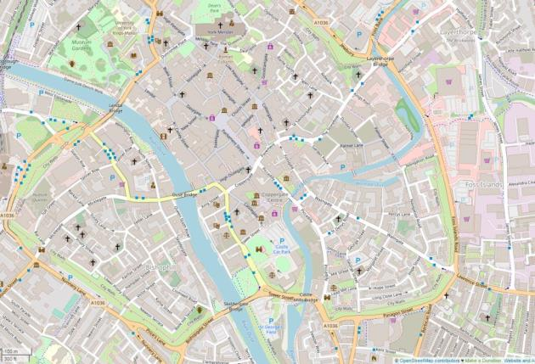

Latitude and longitude

You may be asked to locate a country or feature by latitude and longitude. Remember to always give latitude first (north or south) and longitude second (east or west).

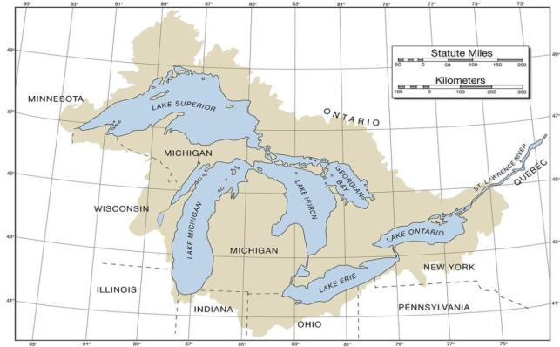

**1.**

**2.**

**3.**

**4.**

**5.**

**X.**

|  |  |
| --- | --- |
| You could be given a world map or a map of an individual country or state.  Give the latitude and longitude for the numbers on the map:  X. 50°N 88°W | Latitude and longitude quiz  What is the name of the line at 0° latitude?    What is the name of the line at 0° longitude?    How many degrees away from the equator are the Tropics of Cancer and Capricorn?    How many degrees away from the equator are the poles? |
| **Hint:**  Consider where the location is on the globe. For example the above map shows a location **north** of the equator and **west** of the Greenwich meridian. | |

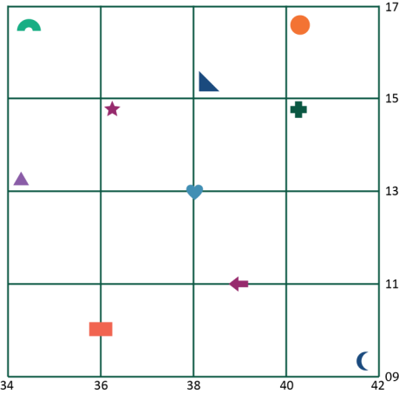

Sometimes you may need to be more precise when giving latitude and longitude references (like when giving six-figure grid references). You will need to include a further figure to note how far along or up the square the location is.

E.g. the latitude and longitude of the cross symbol  is: 13°5’N 40°9’E

Give the latitude and longitude of the following symbols:

|  |  |  |  |
| --- | --- | --- | --- |
|  |  |  |  |
|  |  |  |  |
|  |  |  |  |
|  |  |  |  |
|  |  |  | 13°5’N 40°9’E |

Synoptic charts

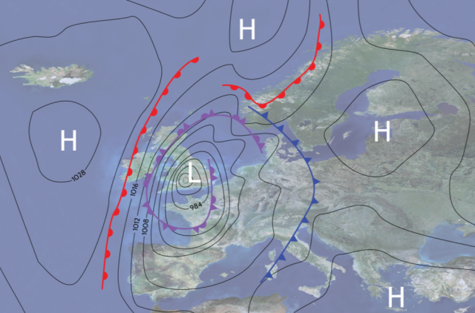

A synoptic chart is a map which shows the weather conditions for a particular area. It will show precipitation, wind speeds, atmospheric pressure, cloud cover and wind direction. The charts are ever-changing as weather fronts move and the atmospheric conditions change.

In your exam you won’t need to draw a synoptic chart but you will be expected to have a good understanding of what they show.

The lines on the map are isobars; these join together lines of equal atmospheric pressure. The higher the number, the higher the pressure. The closer the lines are together the higher the wind speed.

**Questions:**

1. What do the red lines with semicircles indicate?
2. What do the blue lines with triangles indicate?
3. What do the purple lines with semicircles and triangles indicate?
4. What would you expect the weather to be over the Irish Sea?
5. What type of atmospheric pressure is found over the UK?

Constructing a cross section

A cross section shows how relief (height) changes along a chosen route. They are shown on a graph.

For this task you will need some graph paper.

1. Using the diagrams below, construct two cross sections.

**Diagram A**

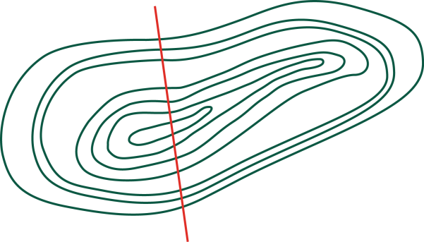

0

100

200

300

**Diagram B**

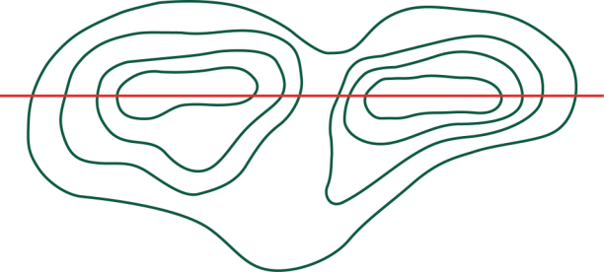

100

200

|  |
| --- |
| 1. Describe the relief of the land of the two diagrams.   Diagram A: |
| Diagram B: |