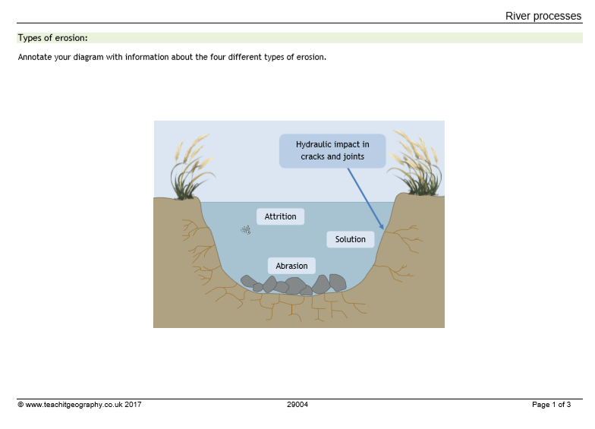

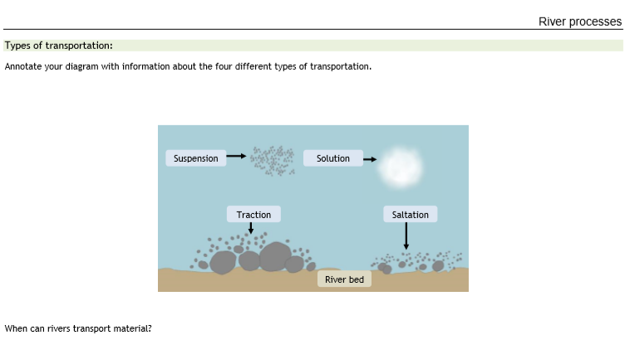
……………………………………………………………………………………………………………………………………………………………………………………………………………………………………………………………………………………………………………………………………………………………………………………………………………………………………………………………………………………………………………………………………………………………………………………………………………………………………………………
..................................................................................................................................................................
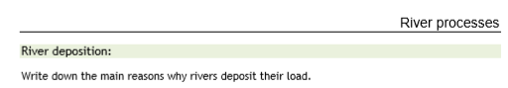
………………………………………………………………………………………………………………………………………………………………………………………………………………………………………………………………………………………………………………………………………………………………………………………………………………………………………………………………………………………………………………………………………………………………………………………………………………………………………………………………………………………………………………………………………………………………………………………………………………………………………………………………………………………………………………………………………………………………………………

River Processes Summary Table – Write the definitions of these key words
SOLUTION
ABRASION
ATTRITION
HYDRAULIC ACTION
TRACTION
SALTATION
SUSPENSION
DEPOSITION

