YEAR 10 past paper questions: Unit 1 (Learning Aim B)

Attempt ALL questions (the number of marks available is in brackets for each question)

- There are different methods of strength training. Identify two training methods that would improve strength (2)

Static Stretching

Circuit Training

Fartlek Training

Interval Training

Free Weights

- Flexibility training is important for all sports performers. Each picture (A and B) shows a type of stretch. What are the types of stretches shown? (2)

Picture A:

Picture B:

- Explain why a tennis player would adapt Fartlek training to suit the needs of their sport (2)

- Name one training aid that can be used in Fartlek training to increase intensity (1)

- Which aspect of fitness is most commonly used through continuous training? (1)

- Look at the table below showing heart rate data for marathon runners who are using continuous training in preparation for a race.

Fill in the missing gaps to show the correct heart rate for these athletes if they were working within their aerobic training zone. You may use the box below for your workings. (6)

Name | Age (Years) | HRmax (bpm) | Aerobic zone (60%) lower limit (bpm) | Aerobic zone (85%) upper limit (bpm)
Di | 68 |  | 91 | 129
Dave | 50 | 170 | 102
Minsuh | 34 |  | 112
Adam | 20 |  |  | 170

Use this box for your workings

- Describe one key feature of interval training (1)

- Identify one purpose of rest periods in Interval training (1)

- Laura is a high jumper.

She uses plyometric training. Explain one reason why this type of training would be beneficial to her performance (2)

- Give 2 disadvantages of plyometric training (2)

- Which one of these is not a type of speed training? Put an X in the box (1)

Hollow sprints
Sprint intervals

Box sprints

Acceleration sprints

- Name the type of speed training that is made up of a type of a series of sprints and rest periods, where rest periods may include walking or jogging (1)

- State two components of fitness that weight training helps to develop (2)

- Explain the term 1RM (1)

- An athlete is training at 50-60% of their 1RM. Which type of strength is this helping to build? (1)

- Jess is competing a circuit that is aimed to improve her Aerobic endurance, with exercise including shuttle runs, skipping, burpees and step ups. She is working for 30 seconds at each station with 10 seconds rest.
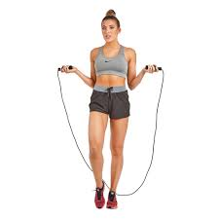

Describe 2 ways in which exercise intensity could be increased on this circuit (4)

Learning Aim B longer exam question (8 marks)

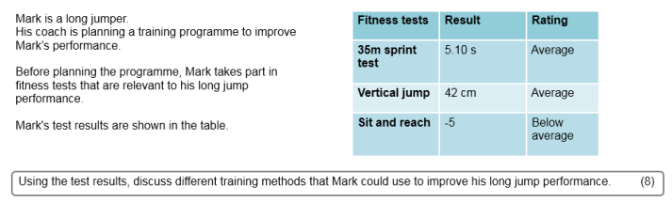

END OF TEST

